At Temple Beth-El * 5 Old Mill Road, Great Neck, New York 11023
516.487.0900 ext. 209 *516.621.8200*212.658.1519*203.918.2301
wkosherevents.com

PASSOVER CATERING MENU 2024
ORDER DEADLINE APRIL 14, 2024 BY 12:00PM
Glatt Kosher Under The Kof-K Supervision

Seder Plate – All The Fixings
Roasted Egg, Chicken Neck, Parsley, Charoset, Horseradish Root Without The Plate $45.00
Roasted Lamb Shanks $20.00 Each – Roasted Eggs $1.00 Each

Appetizers and Salads
Homemade Gefilte Fish, Horseradish ..........................................................................................$4.75 Per Portion
Moroccan Carrot SaladⓋ....................................................................................................................... $14.00 Pint
Creamy Coleslaw-V................................................................................................................................ $11.00 Pint
Roasted Beet SaladⓋ….............................................................................................................................$13.00 Pint
Grandma Irma’s Chopped Liver............................................................................................................ $26.00 Pint
Quinoa & Wheatberry Salad, Shaved CucumberⓋ…..............................................................................$17.00 Pint
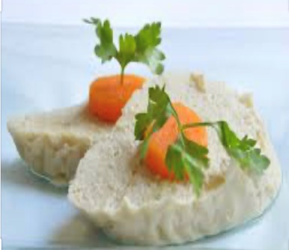
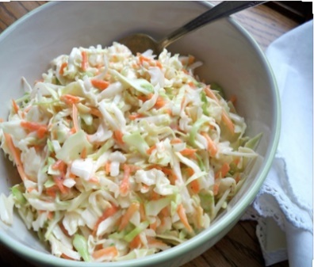
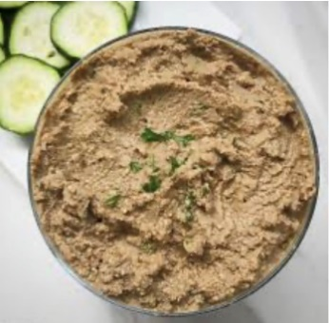
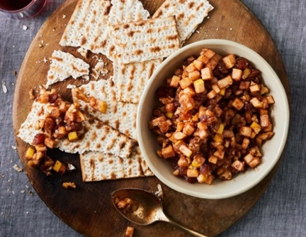
Charoset. Ⓥ.............................................................................................................................................$14.50 Pint

Soups
Butternut Squash Soup-V......................................................................................................................$24.00 Quart
Vegetable SoupⓋ..................................................................................................................................$20.00 Quart
Chicken Soup........................................................................................................................................$20.00 Quart
Matzoh Balls-V........................................................................................................................................$3.75 Each
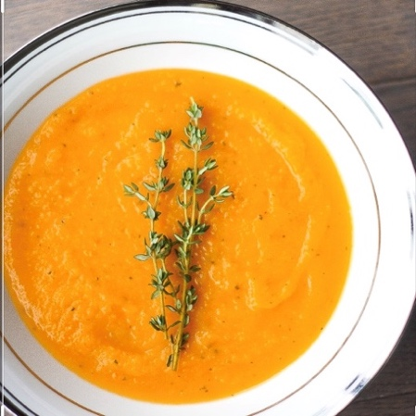
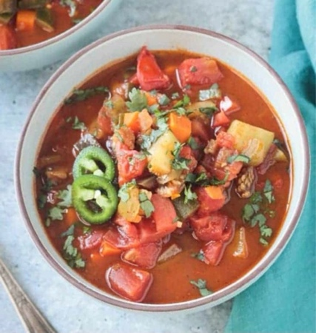
At Temple Beth-El * 5 Old Mill Road, Great Neck, New York 11023
516.487.0900 ext. 209 *516.621.8200*212.658.1519*203.918.2301
wkosherevents.com

PASSOVER CATERING MENU 2024
ORDER DEADLINE SUNDAY APRIL 14, 2024 BY 12:00PM
Entrees
Whole Roasted Turkey, Gravy.......................................................................................................................$235.00 16-18 lbs.
Herb Crusted French Cut Breast Of Chicken, Sauce Of Wild Mushrooms.................................................... $17.00 Per Breast
Schnitzel.....................................................................................................................................................$17.00 Per Schnitzel
Whole Roasted Or BBQ Chicken.........................................................................................$38.00 Per Chicken Cut In Eighths
Chateaubriand, Sauce Of Bordelaise..............................................................................................................$150.00 Serves 6
Marinated Aged Top Of The Rib Steak........................................................................................................$165.00 Serves 3-4
Pomegranate Braised Short Ribs.................................................................................................................$145.00 Serves 3-4
Roasted Rack of Veal Plume De Veal, Sauce of Black Currants……………………………………………….…$270.00 Serves 6
Hungarian Stuffed Cabbage...................................................................................................................................$14.50 Each
Hungarian Vegan Stuffed Cabbage………………………………………………………………………………………...$14.50 Each
Sweet N’ Sour Meatballs................................................................................................................................$27.00 Per Dozen
Braised Brisket, Gravy...................................................................................................................................$43.00 Per Pound
Chicken Tenders............................................................................................................................................$25.00 Per Pound
Vegan Eggplant Rollatini…………………………………………………………………………………………..…….….$15.00 Each
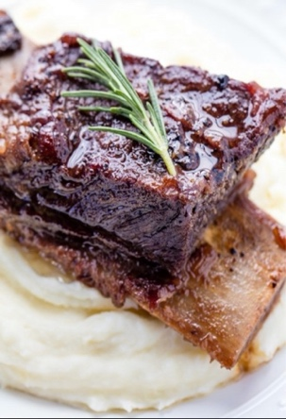
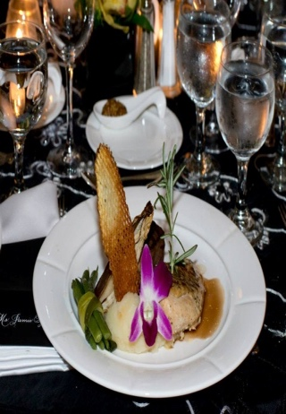
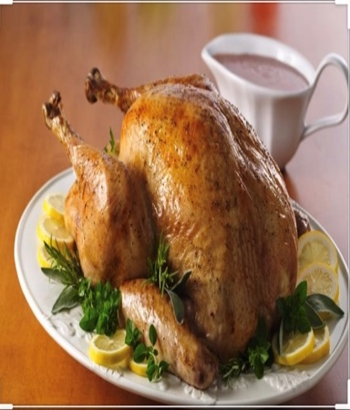
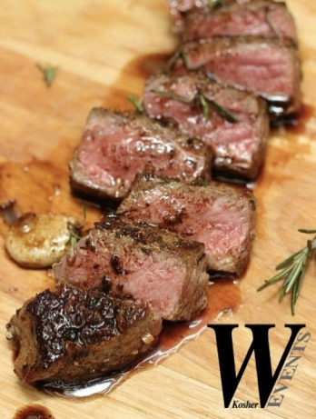
Mediterranean Grilled Salmon, Meyer Lemon Sauce........................................................................$20.50 Per 6 Ounce Piece

Side Dishes
Roasted PotatoesⓋ..........................................................................................................................$22.00 9x13 Pan
Garlic Mashed PotatoesⓋ...............................................................................................................$17.00 9x13 Pan
Mashed Sweet PotatoesⓋ........................................................................................................... .$20.00 9X13 Pan
Chef’s Garden Vegetable MedleyⓋ................................................................................................$47.00 9x13 Pan
Carrot TzimmesⓋ............................................................................................................................$18.50 9x13 Pan
Roasted Butternut SquashⓋ............................................................................................................$53.00 9x13 Pan
Potato Kugel-V...............................................................................................................................$53.00 9x13 Pan
Matzoh Kugel-V…..........................................................................................................................$53.00 9x13 Pan
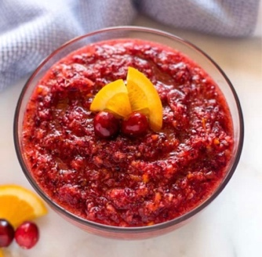
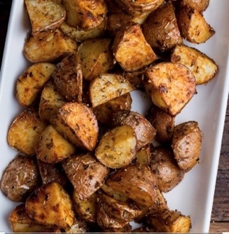
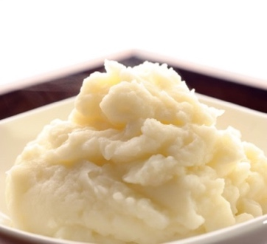
Cranberry Relish..............................................................................................................................$16.50 Per Pint
At Temple Beth-El * 5 Old Mill Road, Great Neck, New York 11023
516.487.0900 ext. 209 *516.621.8200*212.658.1519*203.918.2301
wkosherevents.com

PASSOVER CATERING MENU 2024
ORDER DEADLINE SUNDAY APRIL 14, 2024 BY 12:00PM

Desserts
Small(10”) Fresh Fruit Platter........................................................................................................................$60.00
Large(14”)Fresh Fruit Platter......................................................................................................................$100.00
Fresh Apple Cobbler W/ Crumb Topping..........................................................................................$35.00 Rd Pan
Chocolate Covered Macaroons.....................................................................................................$26.00 Per Dozen
Hazelnut Mousse Mason Jars...................................................................................................................$6.75 Each
Strawberry Cobbler Mason Jars..............................................................................................................$6.75 Each
10” Chocolate Chip Cookie Cake...................................................................................................................$68.50
10” Strawberry Cake.......................................................................................................................................$68.50
14” Blueberry Tart..........................................................................................................................................$68.50
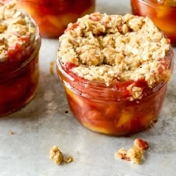

Seder To Go Box – Serves 6 People $480.00

Seder To Go Box – Serves 4 People $340.00

Seder Plate To Include – Roasted Egg, Parsley, Roasted Chicken Neck, Charoset, Horseradish Root
Hard Boiled Eggs And Charoset Family Style

Gefilte Fish, Sliced Carrots, Horseradish
Chicken Matzoh Ball Soup And Creamy Coleslaw Family Style
Braised Brisket W/ Gravy And Roasted Chicken
Chefs Garden Vegetables
Potato Kugel And Roasted Potatoes W/ Fresh Rosemary
Chocolate Drizzled Macaroons And Fresh Fruit W/ Berries

Ⓥ-Vegan V- Vegetarian
Glatt Kosher Under The Kof-K Supervision

At Temple Beth-El * 5 Old Mill Road, Great Neck, New York 11023
516.487.0900 ext. 209 *516.621.8200*212.658.1519*203.918.2301
wkosherevents.com

To Order:
Contact us at 516-621-8200 or info@wkosherevents.com to place an order
ORDER DEADLINE SUNDAY APRIL 14TH, 2024 BY 12:00PM

Pickup/Delivery:
Food can be picked up at Temple Beth-El Of Great Neck or Temple Beth El of Stamford
Delivery $25.00 within the Great Neck Community
Out of town delivery fees vary
Shipping to Florida Priced Accordingly
Great Neck Curbside Pick Up Available Sunday April 21st 11:00AM – 2:00PM
All Deliveries Will Be Made On Sunday April 21st
Curbside Pick Up - Stamford Connecticut At Temple Beth El Of Stamford
Pick Up Sunday April 21st 1:00PM – 3:00PM

Payment:
Cash, Check, or Credit Card. Credit Card charges 4% fee applied
Minimum $50.00 And 50% Due When Ordering

Staff to assist you in your home available upon request and based on availability
Special requests can be accommodated upon request and priced accordingly

Glatt Kosher Under The Kof-K Supervision

